# Lasso, Ridge, and ElasticNet Regression

**Instructions:**

Please share your answers filled in-line in the word document. Submit code separately wherever applicable.

Please ensure you update all the details:

**Name: Seems Iyengar Batch ID: DataScience_03052023_10AM(20032023)**

**Topic: Lasso, Ridge, and ElasticNet Regression**

**Guidelines:**

**1. An assignment submission is considered complete only when the correct and executable code(s) and documentation explaining the method and results are submitted. Failing to submit either of those will be considered an invalid submission and not a correct submission.**

**2. Ensure that you submit your assignments correctly and in full. Resubmission is not allowed.**

**3. Post the submission you can evaluate your work by referring to the keys provided. (will be available only post the submission).**

**Hints:**

1. **Business Problem**
   1. **What is the business objective?**
   2. **Are there any constraints?**
2. **Work on each feature of the dataset to create a data dictionary as displayed in the below image:**

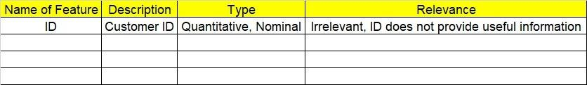**Make a table as shown above and provide information about the features such as its data type and its relevance to the model building. And if not relevant, provide reasons and a description of the feature.**

1. **Data Pre-processing**

**3.1 Data Cleaning, Feature Engineering, etc.**

**3.2 Outlier Treatment.**

1. **Exploratory Data Analysis (EDA):**
   1. **Summary.**
   2. **Univariate analysis.**
   3. **Bivariate analysis.**
2. **Model Building**
   1. **Build the model on the scaled data (try multiple options).**
   2. **Perform Lasso, Ridge, and Elastic Net Regressions.**
   3. **Train and test the model and compare RMSE values. Tabulate R-Squared and RMSE values for different models in the documentation and provide an explanation.**
   4. **Briefly explain the model output in the documentation.**
3. **Write about the benefits/impact of the solution - in what way does the business (client) benefit from the solution provided?**

**Problem Statements:**

1. An analytics company has been tasked with the crucial job of finding out what factors affect a startup company and if it will be profitable or not. For this, they have collected some historical data and would like to apply multilinear regression to derive brief insights into their data. Predict profit, given different attributes for various startup companies.

